**Project Title: Air Q Assessment TN**

Phase 1: Project Definition and Design Thinking

**Project Definition**: The project aims to analyze and visualize air quality data from monitoring stations in Tamil Nadu. The objective is to gain insights into air pollution trends, identify areas with high pollution levels, and develop a predictive model to estimate RSPM/PM10 levels based on SO2 and NO2 levels. This project involves defining objectives, designing the analysis approach, selecting visualization techniques, and creating a predictive model using Python and relevant libraries.

**Design Thinking:**

* 1. **Project Objectives:**

Air Pollution is the crucial Air pollution is the crucial type of ecological direct effect on ecological balance and harms human health. The growing economy of a country is actually leading to its atmosphere. According to WHO, Air contamination ruin around seven million persons worldwide in a year. Also, WHO determines that the global populations (99%) breathe air contains dangerous pollutants exceeding the WHO guideline limit. The acceleration of industrialization, the fast expansion of urbanization, and the status of urban air effluence has become worst, which badly impacts living environment and health. This deep case study focuses mainly upon the major causes and pollutants in TamilNadu, Chennai for more than a decade covering the urban, rural, coastal and industrial area. This recommended work explores and inspects the air pollutant levels of Chennai across different geographical locations from spatiotemporal perspective. And, this suggested big data analytics framework intends air pollution analytics and verdicts related to people affected with various diseases influenced by the components of ambient air fineness. Innovative and creative method of managing challenges of big data gathered from Satellites, weather and sensor of CPCB, NEERI and Meteorology department of various parts of chennai over the decade to be formed using Hadoop distributed Architecture incorporating Machine learning systems. The outcome of such analytics will be beneficial to the society conveying significant recommendations to the government to manage the air pollution crisis and the findings pinpoints the causes of pollution.

**2. Analysis Approach**

Understating the pattern of AQI for the period of four years To analysis the AQI pattern of a station T-Nagar(commercial zone) in Chennai city, daily study on the AQI values were made over the past days The continuous observation of AQI values were obtained from TNPCB website (tnpcb.gov.in). The data used for analysis is from the air monitoring station located at T-Nagar as indicated in Fig. 1. Table 1 provides the statistics of AQI values of all five monitoring stations It was observed that AQI level during 2022-2023 was lies in the satisfactory category except for station Anna Nagar in 2023.

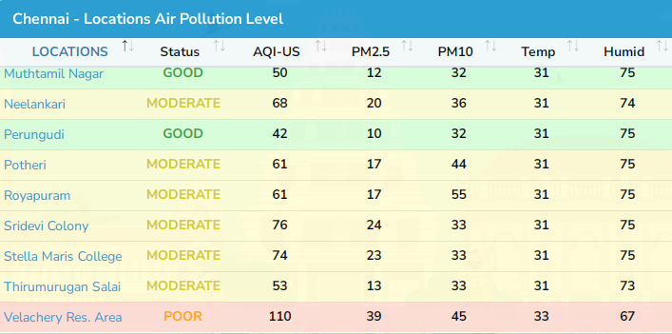

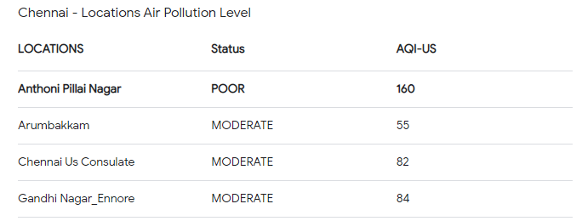

**3. Visualization Selection**